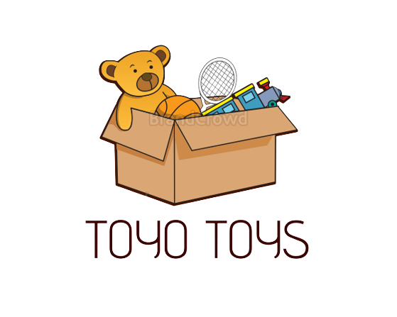

***GROUP MEMBERS:* ID1358755 RANA FAHAD JAVED**

**ID:1365677 M. SUBHAN ALI KHAN**

Contents

**CERTIFICATE OF COMPLETION** 5

**ACKNOWLEDGEMENT** 6

***Functional Requirement*** 7

***Hardware and Software Requirements*** 9

***Website Features*** 10

**USER GUIDE** 11

**HOMEPAGE(landing page)** 11

**CONTACT US** 11

**ABOUT US** 12

**BRANDS** 12

MATTEL 12

WINFUN 13

BABY EINSTEIN 13

13

LEGO 14

BARBIE 14

WOODLETS 15

DEVELOPER’S GUIDE: 16

HOMEPAGE: 16

TOYS FOR BOYS: 16

TOYS FOR GIRLS: 16

BRANDS: 17

CONTACT US: 17

LOCATION: 17

ABOUT US: 17

# **CERTIFICATE OF COMPLETION**

This is to clarify that **Rana Fahad Javed** and **M.Subhan Ali Khan** have successfully completed our AACP Semester 1 E-Project.

Submitted to Aptech Computer Education on

July 30th,2022

# **ACKNOWLEDGEMENT**

*First of all we would like to thank Almighty Allah for giving us strength and ability to complete this project.*

*And then, we would like to express our special thanks of gratitude to our teacher* ***Sir Faizan Sabir*** *who guided us on the project Toyoos, which also helped us in doing a lot of new learning and we came to know about so many new things we are really thankful to him.*

*We earnestly hope that this project will provide all the necessary information required by the user to fulfill his/her inspiration. However, suggestion and Feedbacks for improvements will be thankfully welcomed & acknowledged.*

BABY EINSTEIN

WINFUN

WOODLETSS

BBARBIE

LOCATION

TOYO TOYS

CONTACT US

LELEGO

MATTEL

FOR BOY

FOR GIRL

COMPARE

ABOUT US

GUIDE

BRANDS

TOYS

HOMEH

# ***Functional Requirement***

1. Home Page
2. Shop By Age
3. Popular Products
4. Toys
5. Toys for Boys
6. Toys for Girls
7. Brands
8. Mattel
9. Lego
10. Baby Einstein
11. Winfun
12. Woodlets
13. Barbie
14. About Us
15. Customer Guide
16. Contact Us
17. Location
18. Compare Page

***Problem Statement:***

TOYO Toys is selling various types of Toys. Company has a huge collection of Toys for different segments of kids. The company advertises by distributing the pamphlets, advertising on television and so on. Due to rapid development in internet field, the company decides to launch a website where people will get all the information about the various products available with them easily.

# ***Hardware and Software Requirements***

**Hardware**

* A minimum computer system that will help you access all the tools in the courses is a Pentium 166 or better
* 64 Megabytes of RAM or better

**Software**

* Notepad/HTML editor
* Dreamweaver
* IE 5.0/ Netscape 6.0

# 

# ***Website Features***

This website TOYO TOYS deals with all the content that a customer wants to see in at any good toys website where they can each type of toy at single place. We have given age groups that will also help in selection of toy.

They can even contact us if they have any queries.

# **USER GUIDE**

## **HOMEPAGE(landing page)**

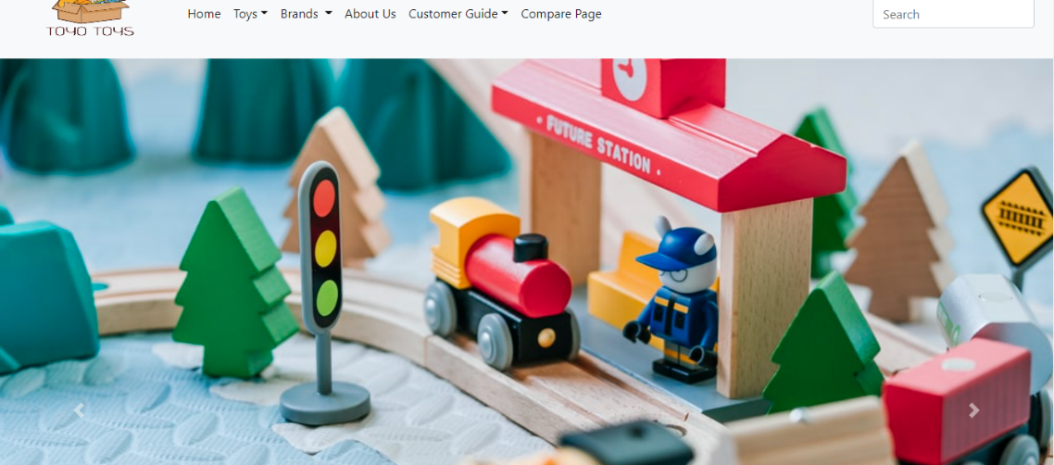

## **CONTACT US**

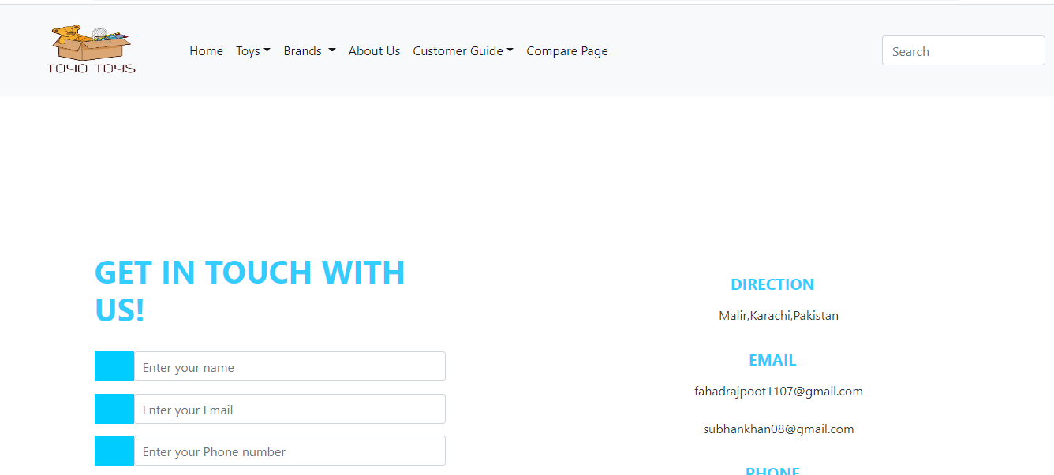

## **ABOUT US**

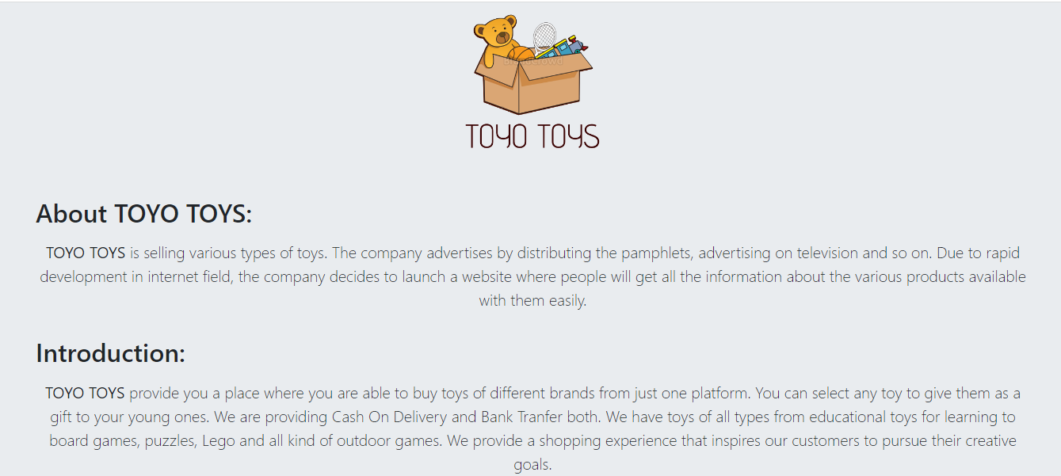

## **BRANDS**

## MATTEL

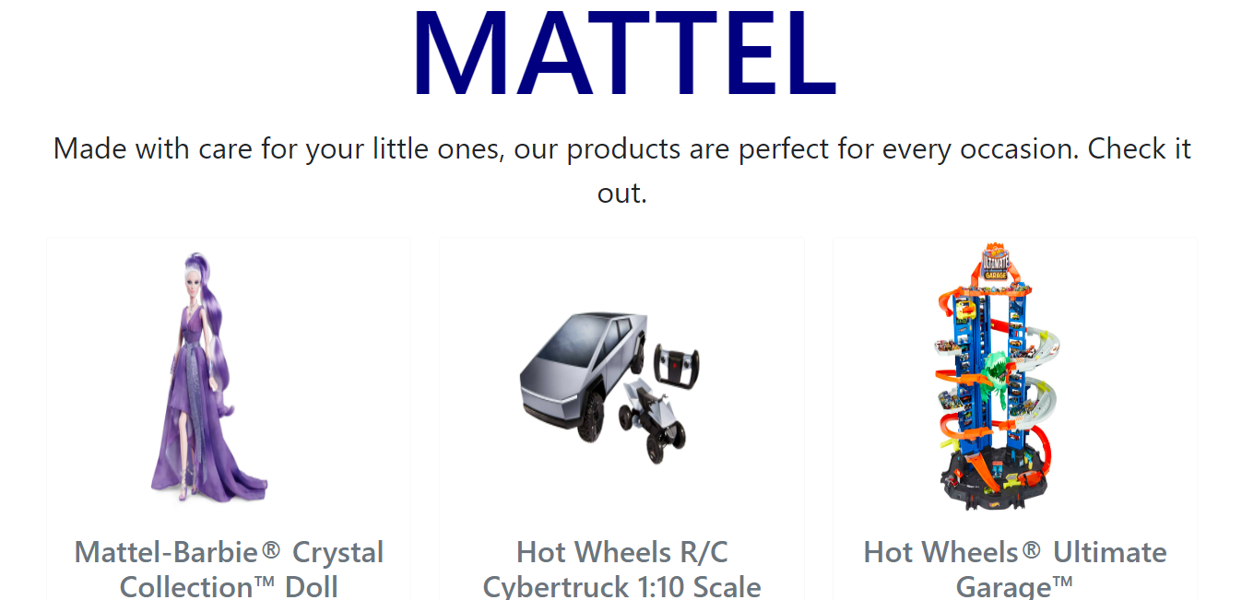

## WINFUN

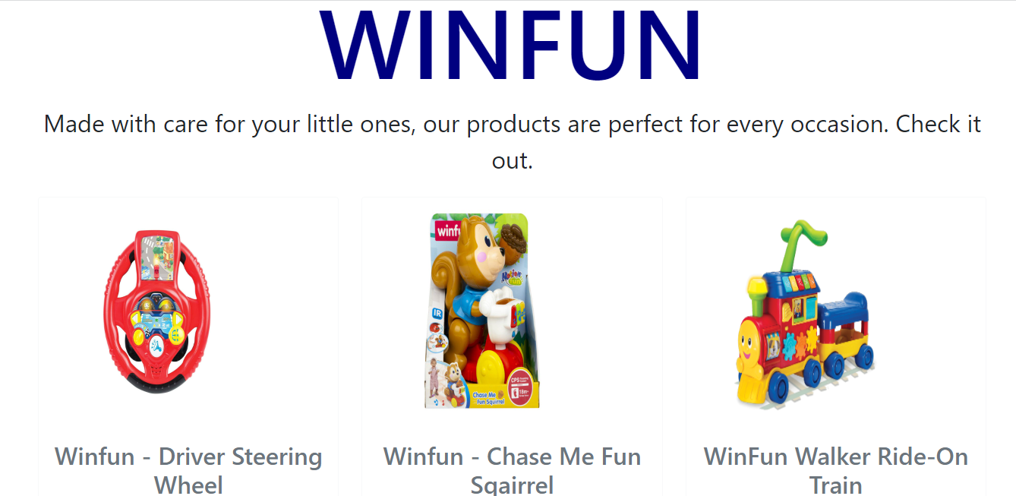

## BABY EINSTEIN

## 

## LEGO

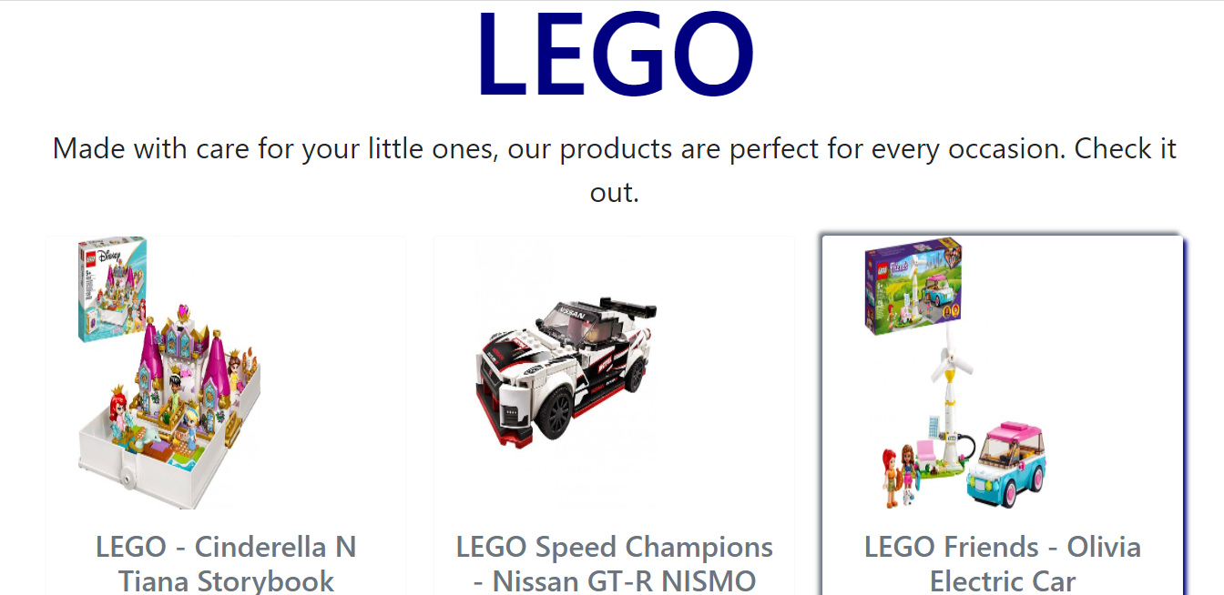

## BARBIE

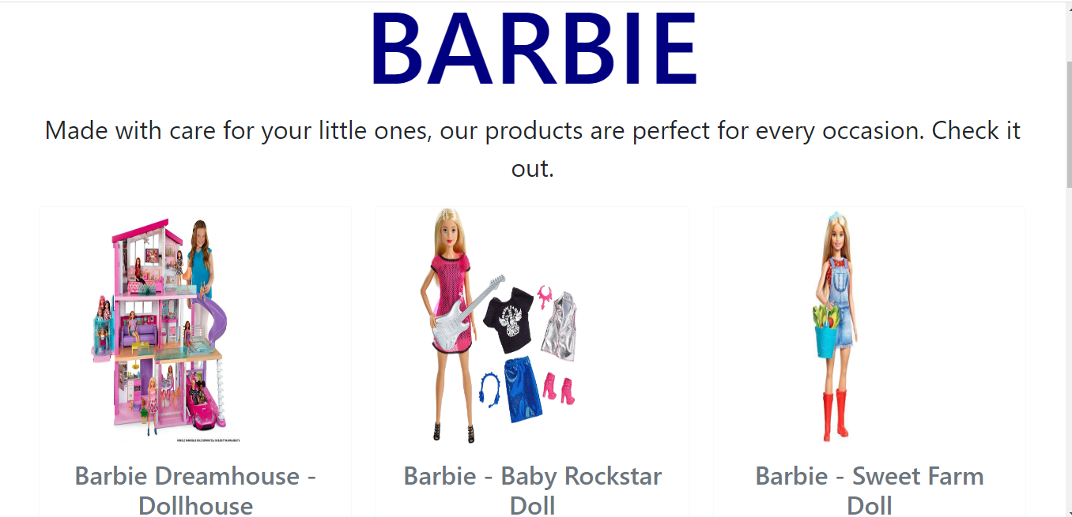

## WOODLETS

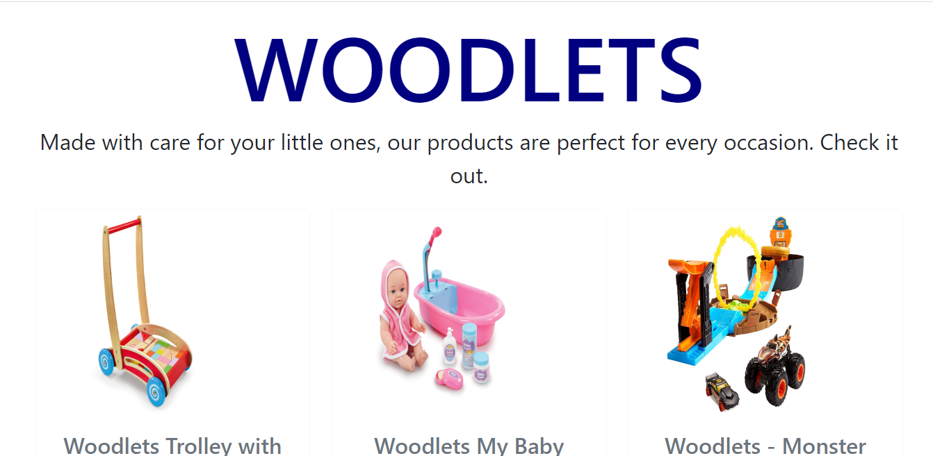

# DEVELOPER’S GUIDE:

We have used html , css and bootstrap for making our website.

### HOMEPAGE:

In homepage first of all here comes a navbar that contains tabs with dropdowns. After that we gave a curosel containing three sliders and then the age limit section starts where there are three divs . Last for homepage we gave our popular products by using cards.

### 

### TOYS FOR BOYS:

It comes as a dropdown item in toys tab given in navbar. Here we use nine cards for giving images and detail about the product including price,features and for which age the product will be good.

### TOYS FOR GIRLS:

It comes as a dropdown item in toys tab given in navbar. Here we use nine cards for giving images and detail about the product including price,features and for which age the product will be good.

### BRANDS:

This tab contains six dropdown items mattel,lego,baby Einstein,winfun,woodlets,Barbie. All these dropdown item will use for opening page for the desired brand. Each brand contains nine cards with images, features and prices of the product.

### CONTACT US:

We have given a form in contact us page. On the other hand we have given our email addresses and contact numbers.

### LOCATION:

Here we gave the park location map.

### ABOUT US:

Here we gave introduction about our website, the aim of making the TOYOOS website, and our team members.